Experiment- 1
Branch: MCA (AI&ML) | Semester: 2
Student Name: Ajay Rakwal | UID: 25MCI10329
Subject Name: Technical Training | Subject Code: 25CAP-652
Section/Group: MAM-1(A) | Date of Performance: 11-01-2026

Aim of the program:
To design and implement a sample database system using DDL, DML, and DCL commands, including database creation, data manipulation, schema modification, and role-based access control to ensure data integrity and secure, read-only access for authorized users.

Software Requirements
- Operating System: Windows / Linux
- Database Management System: MySQL / Oracle / PostgreSQL
- SQL Interface: MySQL Workbench /Web Based / pgAdmin

Objective
To gain practical experience in implementing Data Definition Language (DDL), Data Manipulation Language (DML), and Data Control Language (DCL) operations in a real database environment. This will also include implementing role-based privileges to secure data.

Procedure of the Experiment
- Open pgAdmin and connect to the PostgreSQL server.
- Create the Course table with appropriate primary key and NOT NULL constraints.
- Create the Student table with primary key, UNIQUE, and CHECK constraints.
- Create the Enrollment table with foreign key relationships to Student and Course tables.
- Insert sample data into the Course, Student, and Enrollment tables.
- Update records in the Student table and delete records from the Enrollment table.
- Create a new role and grant SELECT privileges on the tables.
- Alter the Student table to add a new column.
- Revoke privileges from the role and drop the Enrollment table.

Practical / Experiment Steps
-- course table
CREATE TABLE Course (
course_id NUMBER PRIMARY KEY,
course_name VARCHAR(50) NOT NULL
);
--student table
CREATE TABLE Student (
student_id NUMBER PRIMARY KEY,
student_name VARCHAR(50) NOT NULL,
email VARCHAR(50) UNIQUE,
age NUMBER CHECK (age >= 18)
);

-- enrollment table
CREATE TABLE enrollment (
enroll_id INT PRIMARY KEY,
student_id INT,
course_id INT,
CONSTRAINT fk_student
FOREIGN KEY (student_id)
REFERENCES student(student_id),
CONSTRAINT fk_course
FOREIGN KEY (course_id)
REFERENCES course(course_id)
);

-- data insertion
INSERT INTO course VALUES (1, 'Artificial Intelligence');
INSERT INTO course VALUES (2, 'Data Science');
INSERT INTO student VALUES (101, 'Ajay', 22);
INSERT INTO student VALUES (102, 'Ravi', 23);
INSERT INTO enrollment VALUES (1, 101, 1);
INSERT INTO enrollment VALUES (2, 102, 2);

--data updatate
UPDATE student
SET age = 23
WHERE student_id = 101;

--data delete
DELETE FROM enrollment
WHERE enroll_id = 2;

-- new role created
CREATE ROLE report_user LOGIN PASSWORD 'report123';

-- grant
GRANT SELECT ON course TO report_user;
GRANT SELECT ON student TO report_user;
GRANT SELECT ON enrollment TO report_user;
--add phone number
ALTER TABLE student
ADD COLUMN phone_no VARCHAR(15);

-- revovke
REVOKE ALL ON course FROM report_user;
REVOKE ALL ON student FROM report_user;
REVOKE ALL ON enrollment FROM report_user;
--table drop
DROP TABLE enrollment;

I/O Analysis (Input / Output)
Input
- Course, Student, and Enrollment table creation queries
- Records inserted into all tables using INSERT commands
- UPDATE query to modify student details
- DELETE query to remove enrollment records
- Role creation and privilege assignment queries
- ALTER TABLE command to add a new column
- REVOKE and DROP TABLE commands
Output
- Course, Student, and Enrollment tables created successfully
- Records inserted, updated, and deleted correctly
- Referential integrity maintained between Student and Course tables
- Data retrieved and displayed correctly using SELECT queries
- Role-based access verified using GRANT and REVOKE operations
- Table structure modified successfully and Enrollment table dropped

OUTPUT:
Access granted to new role:
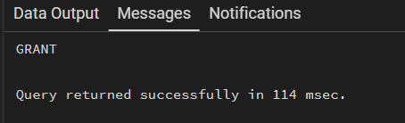

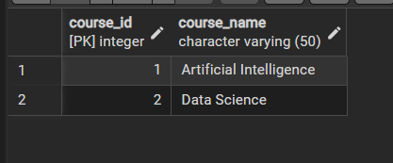
Table Accesed by new role:

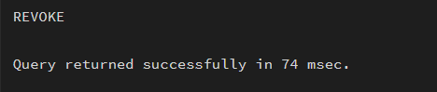
Access revoked:

Accessing after permission revoked:
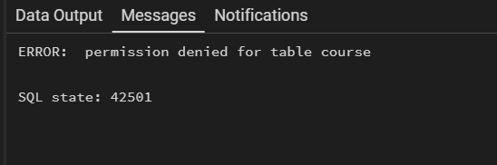

Learning Outcome:
- Learned to create and manage tables using DDL commands in PostgreSQL.
- Understood the use of constraints to maintain data integrity.
- Performed INSERT, UPDATE, and DELETE operations using DML.
- Implemented role-based access control using DCL commands.
- Provided secure read-only access by granting only SELECT privilege.

